## Run Kettle Job for each Row

Shared by: Gilbert Lin

**Problem:**

kjb原參數為指定日期，想增加日期清單參數為另外初始化用



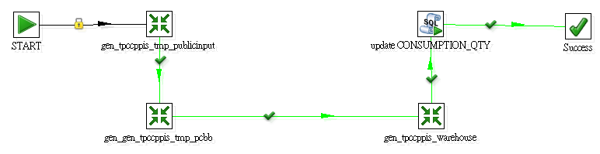

**解決前提:**

1. **多筆日期呼叫時，沒有performance issue**
2. **時間上考量，不想修改main_daily參數為日期區間**

**Solution:**

1. **另開kjb加入原kjb，並於前段增加[gen_sync_date.ktr]與[gen_sync_dates.ktr]**

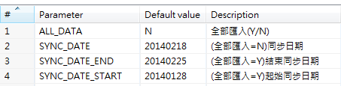

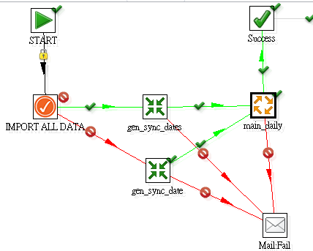

1. **[gen_sync_date.ktr]加入Copy rows result元件，告訴系統要回傳**

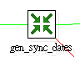

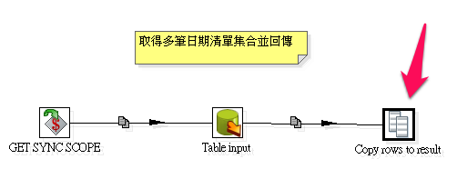

1. **[gen_sync_dates.ktr]加入Copy rows result元件，告訴系統要回傳**



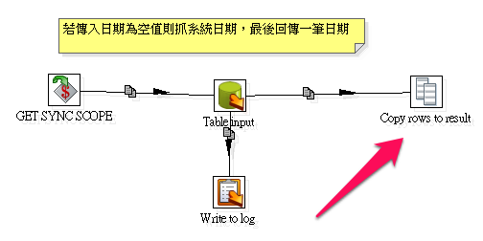

1. **[main_daily.kjb]相關設定**



**設定一**

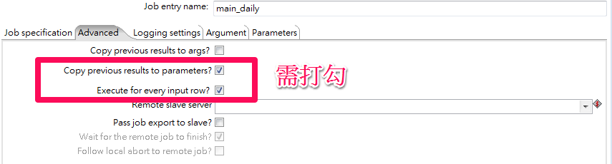

**設定二**

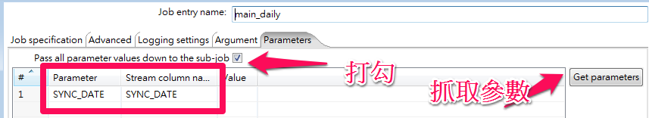

**注意事項:**

1. **.kjb可含.kjb及.ktr ; .ktr只可含.ktr**

**Ref:**

**1.參考網址**

[**http://type-exit.org/adventures-with-open-source-bi/2010/06/run-kettle-job-for-each-row/**](http://type-exit.org/adventures-with-open-source-bi/2010/06/run-kettle-job-for-each-row/)

**2.所做pentaho files**

